How to find Harpenden Arrows
Harpenden Arrows meet at St George’s School Sports Centre Sun Lane, Harpenden, Hertfordshire, AL5 4TD
Park in the Sports Centre car park accessed from Carlton Road (see map) and then walk to the Sports Centre
Please try to arrive by 7:15 pm
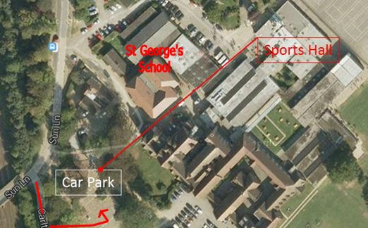
If the car park is full there is another public car park available nearby in Sun Lane / Lydekker Park
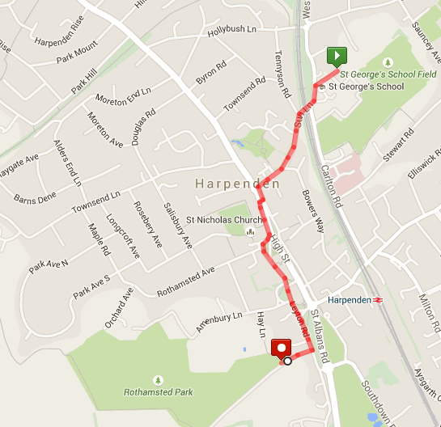
You will be met at the sports centre and then we will jog down to the start of the race in small groups with a run leader.

Getting to the race start
The actual event start and finish is in Rothamsted Park which is less than a mile away (warm up!). If you are running VERY late go straight there – park in the Hay Lane car park – near the swimming pool.
Here is the route we will follow from St George’s to the start.

