Instructions
- Click on the following link - https://cifer.singlewindow.cn

- Click on “Create Account” | 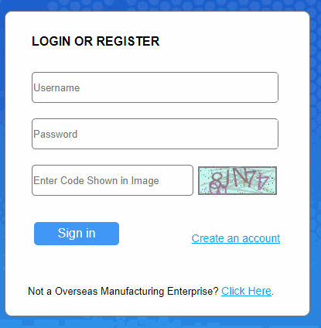
- Select a username of your choice  - Enter a strong password  - Confirm Password  - Note down your username and Password for your record purpose  - Located Country – Select “IND”  - Located Country (Region) Register Number – Enter RCMC No. issued by the Council.  - Workplace – Enter the Enterprise name which should be as per RCMC.  Please make sure that no mistakes are made as the Chinese Officials are very particular.  - Work Department – The department in which the authorised person from the processing unit is submitting application.  - Job title – The designation of the authorised person  - Contacts – the Contact number of authorised person  - Contact Mobile – Mobile no. of authorised person  - Contact Address – Address of the processing unit.  - Email – Email id of the authorised person  - Click on “Register Now” | 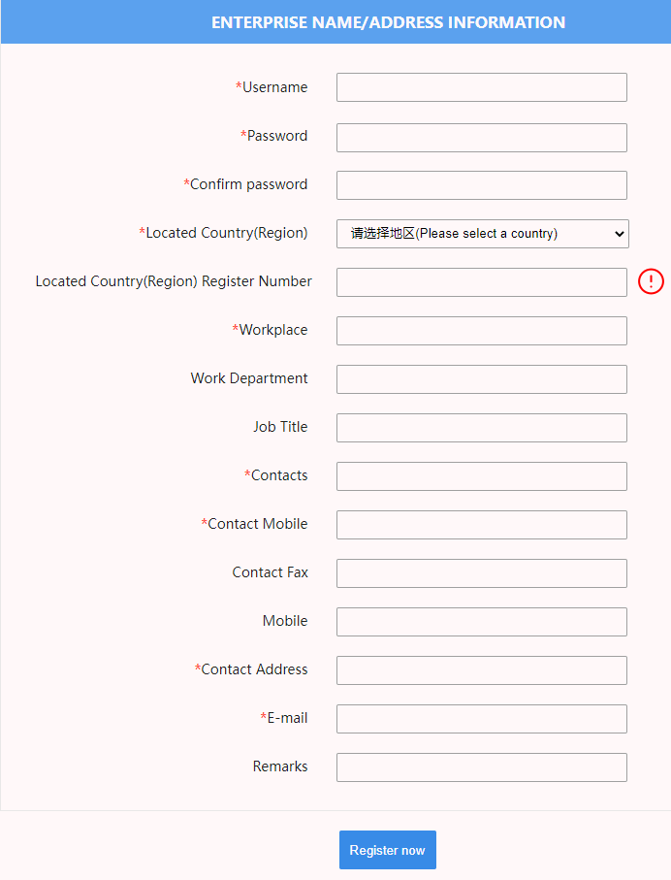

- You will receive a message in Chinese which translates to “Dear user, congratulations on your successful registration! Next, you can log in to the system to complete the information”
- Please send email to IOPEPC “Requesting for Authentication” quoting the username (item 3 above) and RCMC No. (item (7) above to nutan@iopepc.org and ashwini@iopepc.org (both the email ids)
- The Council will send email confirming authentication.
- Please log into the system. After logging in, the following will be shown:
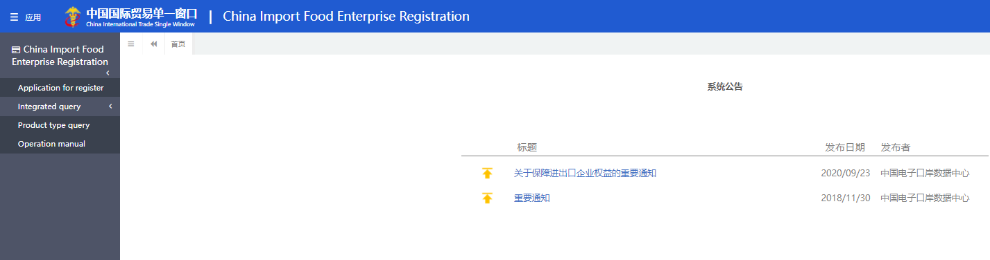
- Click on Application for Register. The following will be shown:

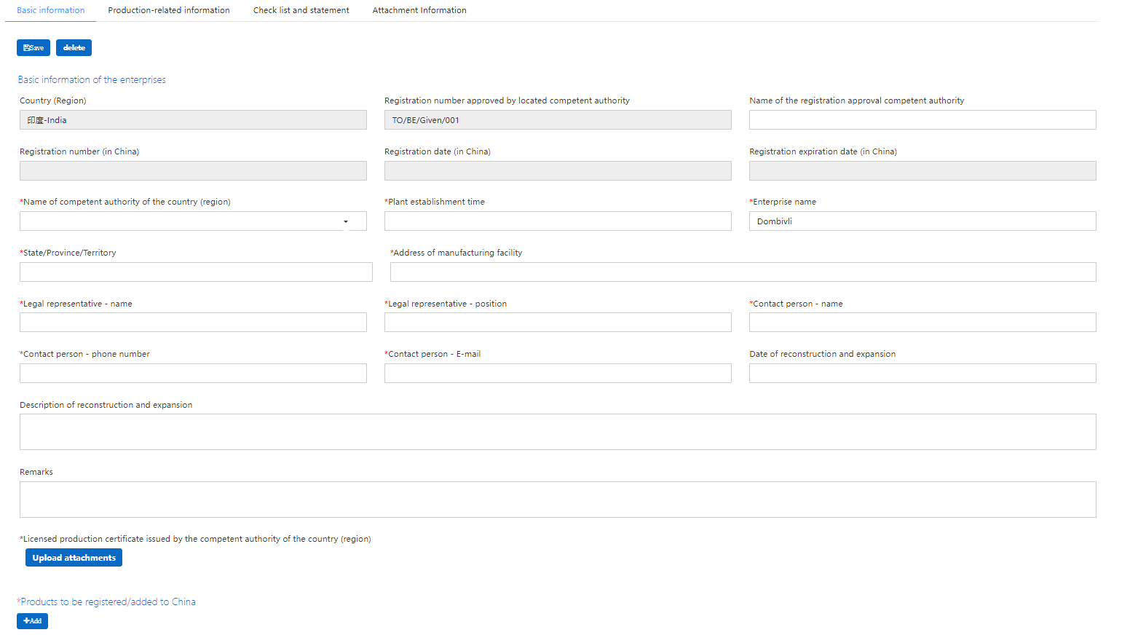

Under “BASIC INFORMATION”

- Name of competent authority of the country (region) : Select INDOPEPC as shown below:
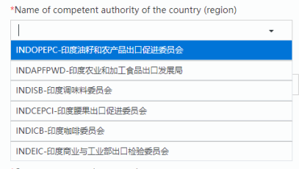

- Fill up relevant details under the tabs namely Basic information, Production-related information, Check list and statement and Attachment Information.
- Review the application and submit.

